Written Report

For

CSC8635 Machine Learning

For the dataset

Fashion MNIST

Simran Choudhary

Student Number

January 27th, 2022

Table of Contents

1. Introduction
2. Project Criteria
3. Methodology
4. Exploratory Findings and Results
5. Evaluation and Future Work

Introduction

This report is a part of Machine Learning with Project coursework. I worked on the Fashion Zalando. The dataset is built in the keras library. The dataset aims to act similar to the MNIST dataset that is used as a baseline for various machine learning models. This project aims to understand and predict the class of an image while looking at various attributes in the pixels in the images. The report consists of the Project criteria, Methodology, exploratory findings, results, evaluation and Future work.

Project Criteria

This project aims to show how we can implement a convolutional neural network on one of the baseline datasets and understand how to implement the theoretical concepts of data science onto a real-world problem. As image data is one of the most popular data to work with, this project shows how to read, pre-process, visualize and understand the data. The major steps involved in this project were as follows:

* Data reading and pre-processing
* Data visualization and analysis
* Convolutional neural network and why it is a powerful tool.

Methodology

The data description was read on the GitHub page to understand the nature of the dataset. The data was divided into 60000 training images and 10000 testing images. The dataset was read using the keras library. The images in the dataset are grayscale, i.e., they are black and white images of clothes. The images were pre-processed and normalized before sending it into a CNN model. After normalizing the dataset, the data was split into training and validation sets. The test set for this dataset was already when the dataset was read from keras library. A convolutional neural network was designed to train on the training dataset. After the neural network was trained, the model was used to predict the classes for the test dataset. The plots for training and validation accuracy were plotted along with the confusion matrix for the test dataset.

Exploratory Findings and Results

The first result received from the data analysis was the uniformity in the target variable, i.e., the dataset was uniformly distributed among the 10 target variables, which showed us that the dataset was a balanced dataset. The dataset had grayscale images which were normalized. One of the normalized grayscale images can be seen below.

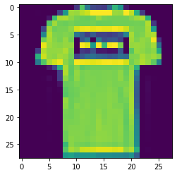

91.3 percent of accuracy was achieved on the test set. High levels of accuracy, precision and recall were achieved which is visible from the classification reports. Along with the precision on test set, high accuracy levels were achieved on the training and validation sets. The scores on the test set from classification report can be seen in the table below.

|  |  |  |  |  |
| --- | --- | --- | --- | --- |
| Classes | Precision | Recall | F1-Score | Support |
| 0 | 0.86 | 0.86 | 0.86 | 1141 |
| 1 | 0.99 | 0.98 | 0.98 | 1181 |
| 2 | 0.86 | 0.88 | 0.87 | 1264 |
| 3 | 0.89 | 0.92 | 0.91 | 1174 |
| 4 | 0.87 | 0.86 | 0.86 | 1199 |
| 5 | 0.98 | 0.98 | 0.98 | 1215 |
| 6 | 0.76 | 0.74 | 0.75 | 1205 |
| 7 | 0.96 | 0.97 | 0.97 | 1190 |
| 8 | 0.97 | 0.98 | 0.98 | 1187 |
| 9 | 0.97 | 0.97 | 0.97 | 1244 |
| Accuracy |  |  | 0.91 | 12000 |

Evaluation and Future work

The model was evaluated on the test set with an accuracy of 91.3 percent. The confusion matrix below precisely shows the correct and incorrect classification.

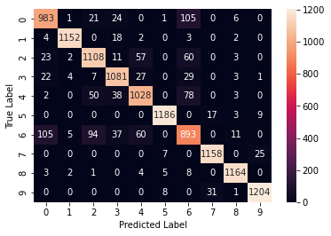

Along with the confusion matrix, the training and validation plot shown below also show a convincing curve about how the neural network was learning from training and validation set.

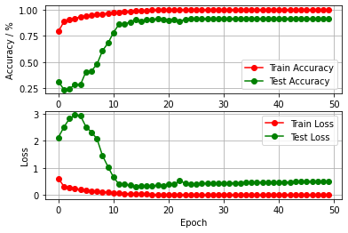

This project gives basic understanding on how we can implement CNN on various datasets. This can be extended into solving real-world problems. After understanding the CNN from this project, this knowledge can be implemented into various industries where we need to process image data.